**Step 1: Figuring valuation multiple for each industry**

**CONSUMER GOODS**

CG <- consumer_goods[rowSums(is.na(consumer_goods)) == 0,]

CGdata <- data.frame(CG)

CG.fit <- lm(formula = price~.,CGdata)

summary(CG.fit)

Call:

lm(formula = price ~ ., data = CGdata)

Residuals:

Min 1Q Median 3Q Max

-66.312 -16.031 -6.087 11.600 155.709

Coefficients:

Estimate Std. Error t value Pr(>|t|)

(Intercept) 15.851026 1.821004 8.705 <2e-16 ***

divyield -19.680178 52.875123 -0.372 0.710

pb 0.020529 0.016587 1.238 0.216

pe 0.001550 0.001541 1.006 0.315

ps 14.775803 1.169331 12.636 <2e-16 ***

---

Signif. codes: 0 ‘***’ 0.001 ‘**’ 0.01 ‘*’ 0.05 ‘.’ 0.1 ‘ ’ 1

Residual standard error: 26.31 on 480 degrees of freedom

Multiple R-squared: 0.2599, Adjusted R-squared: 0.2537

F-statistic: 42.14 on 4 and 480 DF, p-value: < 2.2e-16

Picture:

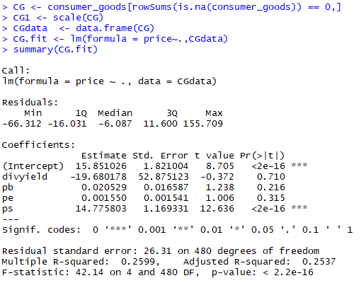

**Financial:**

Fin <- Financials[rowSums(is.na(Financials)) == 0,]

Findata <- data.frame(Fin)

Fin.fit <- lm(formula = price~.,Findata)

summary(Fin.fit)

Call:

lm(formula = price ~ ., data = Findata)

Residuals:

Min 1Q Median 3Q Max

-44.94 -19.46 -10.89 4.42 391.98

Coefficients:

Estimate Std. Error t value Pr(>|t|)

(Intercept) 27.604740 1.464046 18.855 < 2e-16 ***

divyield -1.217918 26.901407 -0.045 0.964

pb 2.701819 0.358486 7.537 8.68e-14 ***

pe 0.002455 0.003454 0.711 0.477

ps 0.021927 0.021578 1.016 0.310

---

Signif. codes: 0 ‘***’ 0.001 ‘**’ 0.01 ‘*’ 0.05 ‘.’ 0.1 ‘ ’ 1

Residual standard error: 40.28 on 1381 degrees of freedom

Multiple R-squared: 0.04064, Adjusted R-squared: 0.03786

F-statistic: 14.63 on 4 and 1381 DF, p-value: 1.049e-11

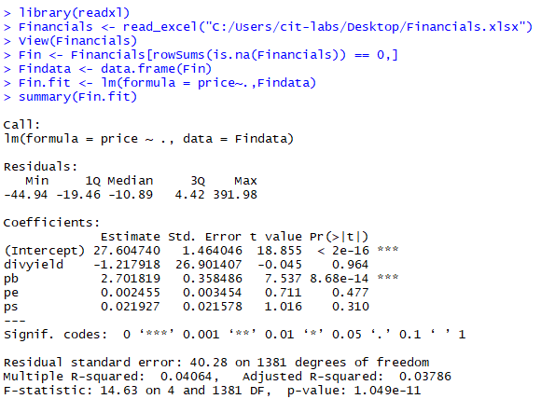

**Basic Materials**

Call:

lm(formula = price ~ ., data = clean_BM)

Residuals:

Min 1Q Median 3Q Max

-152.0 -129.2 -93.7 -40.6 11108.9

Coefficients:

Estimate Std. Error t value Pr(>|t|)

(Intercept) 1.487e+02 3.916e+01 3.798 0.000163 ***

pb 1.327e-02 3.470e+00 0.004 0.996950

pe -1.328e-02 1.977e-01 -0.067 0.946466

ps -4.021e-01 8.131e-01 -0.495 0.621106

divyield -1.318e+03 8.740e+02 -1.508 0.132260

---

Signif. codes: 0 ‘***’ 0.001 ‘**’ 0.01 ‘*’ 0.05 ‘.’ 0.1 ‘ ’ 1

Residual standard error: 751.8 on 538 degrees of freedom

Multiple R-squared: 0.004521, Adjusted R-squared: -0.002881

F-statistic: 0.6108 on 4 and 538 DF, p-value: 0.655

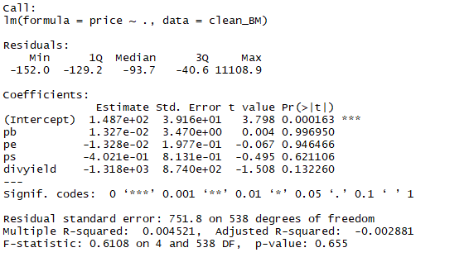

**Healthcare:**

HC <- Healthcare[rowSums(is.na(Healthcare)) == 0,]

HCdata <- data.frame(HC)

HC.fit <- lm(formula = price~.,HCdata)

summary(HC.fit)

Call:

lm(formula = price ~ ., data = HCdata)

Residuals:

Min 1Q Median 3Q Max

-277 -218 -205 -176 109985

Coefficients:

Estimate Std. Error t value Pr(>|t|)

(Intercept) 2.221e+02 1.486e+02 1.495 0.135

divyield -4.085e+02 3.033e+03 -0.135 0.893

pb 2.057e-01 4.296e+00 0.048 0.962

pe -1.225e-02 1.270e+00 -0.010 0.992

ps -1.664e-03 5.693e-02 -0.029 0.977

Residual standard error: 4068 on 768 degrees of freedom

Multiple R-squared: 2.832e-05, Adjusted R-squared: -0.00518

F-statistic: 0.005437 on 4 and 768 DF, p-value: 0.9999

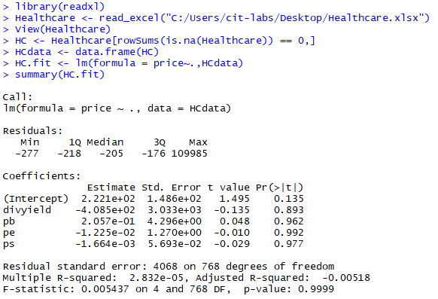

**Technology**

Call:

lm(formula = price ~ ., data = clean_tech)

Residuals:

Min 1Q Median 3Q Max

-116.885 -16.498 -8.724 6.914 244.918

Coefficients:

Estimate Std. Error t value Pr(>|t|)

(Intercept) 17.5941782 1.2266920 14.343 <2e-16 ***

pb 0.0505311 0.0733117 0.689 0.491

pe -0.0002646 0.0005749 -0.460 0.645

ps 3.3299874 0.2828238 11.774 <2e-16 ***

divyield 16.7027493 17.5950276 0.949 0.343

---

Signif. codes: 0 ‘***’ 0.001 ‘**’ 0.01 ‘*’ 0.05 ‘.’ 0.1 ‘ ’ 1

Residual standard error: 29.66 on 1070 degrees of freedom

Multiple R-squared: 0.1191, Adjusted R-squared: 0.1158

F-statistic: 36.16 on 4 and 1070 DF, p-value: < 2.2e-16

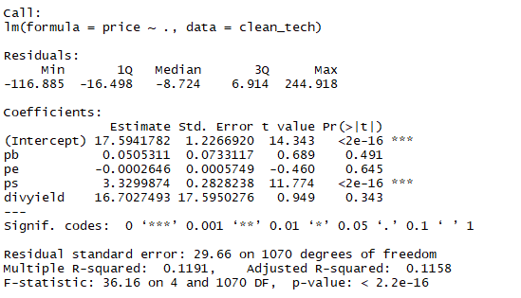

**Industrial:**

Ind <- Industrial[rowSums(is.na(Industrial)) == 0,]

Inddata <- data.frame(Ind)

Ind.fit <- lm(formula = price~.,Inddata)

summary(Ind.fit)

Call:

lm(formula = price ~ ., data = Inddata)

Residuals:

Min 1Q Median 3Q Max

-33.705 -18.904 -8.711 12.074 124.800

Coefficients:

Estimate Std. Error t value Pr(>|t|)

(Intercept) 2.634e+01 1.205e+00 21.859 < 2e-16 ***

divyield 1.483e+02 4.597e+01 3.226 0.00133 **

pb 1.574e-05 4.839e-03 0.003 0.99741

pe 1.961e-02 9.466e-03 2.072 0.03868 *

ps -8.188e-04 8.893e-03 -0.092 0.92666

---

Signif. codes: 0 ‘***’ 0.001 ‘**’ 0.01 ‘*’ 0.05 ‘.’ 0.1 ‘ ’ 1

Residual standard error: 26.15 on 587 degrees of freedom

Multiple R-squared: 0.02412, Adjusted R-squared: 0.01747

F-statistic: 3.627 on 4 and 587 DF, p-value: 0.00624

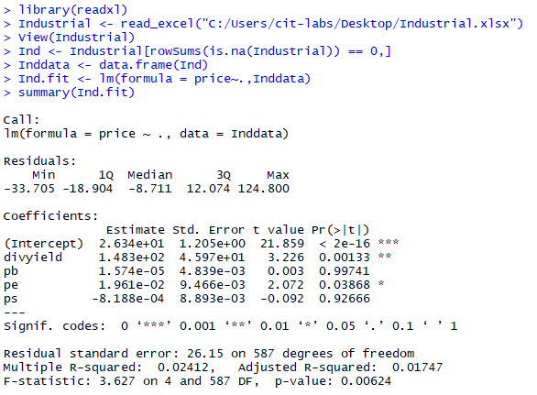’

**Utilities**

Call:

lm(formula = price ~ ., data = clean_utilities)

Residuals:

Min 1Q Median 3Q Max

-45.341 -14.836 -4.288 13.113 64.463

Coefficients:

Estimate Std. Error t value Pr(>|t|)

(Intercept) 22.258125 4.593330 4.846 2.92e-06 ***

pb 5.566694 1.860149 2.993 0.0032 **

pe 0.002518 0.010106 0.249 0.8035

ps 0.936558 1.023967 0.915 0.3617

divyield -23.924962 34.371551 -0.696 0.4874

---

Signif. codes: 0 ‘***’ 0.001 ‘**’ 0.01 ‘*’ 0.05 ‘.’ 0.1 ‘ ’ 1

Residual standard error: 21.1 on 163 degrees of freedom

Multiple R-squared: 0.06533, Adjusted R-squared: 0.04239

F-statistic: 2.848 on 4 and 163 DF, p-value: 0.02569

